FENG HAN 20407369

1. Explicit Umbrella Smooth: Uniform-weight Laplacian iteration 0, 10, 30

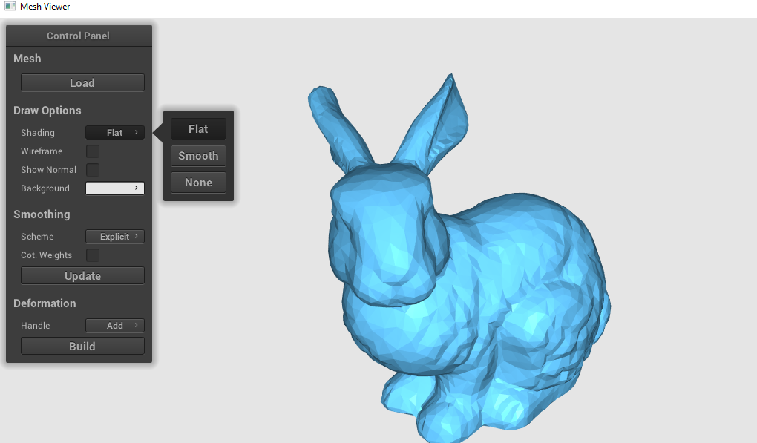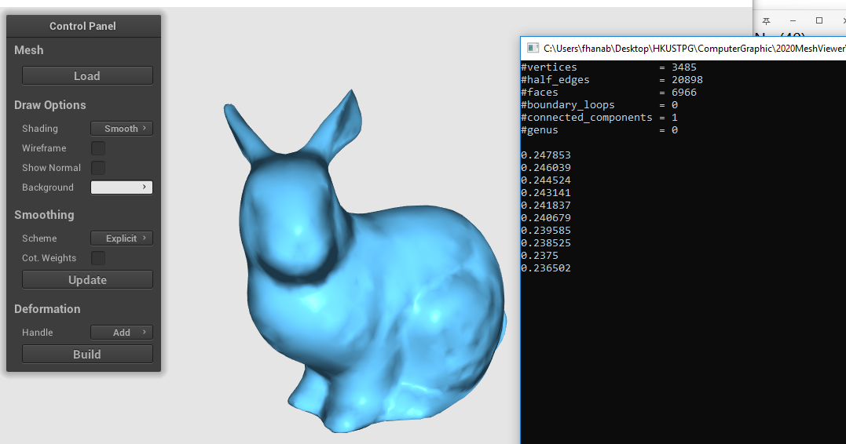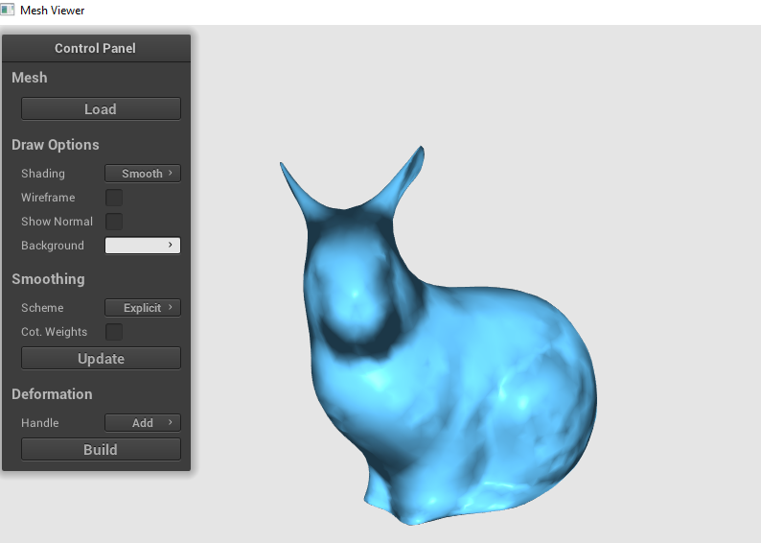

Explicit Umbrella Smooth: Cot-weight Laplacian iteration 0, 10, 30



1. Implicit Umbrella Smooth: Uniform-weight Laplacian iteration 0, 10, 30

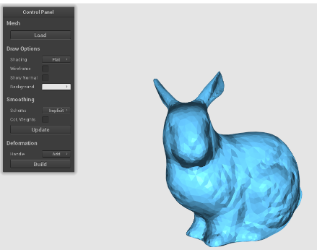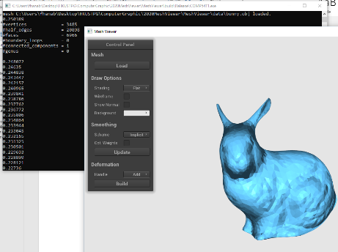

Implicit Umbrella Smooth: Cot-weight Laplacian iteration 0, 10, 30

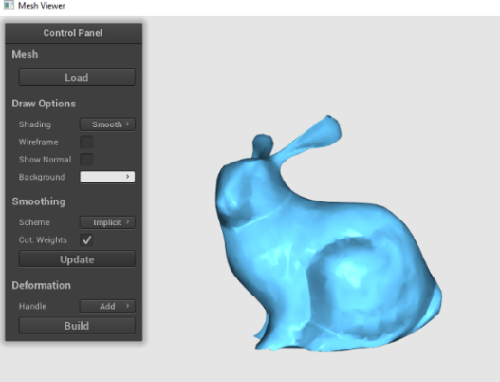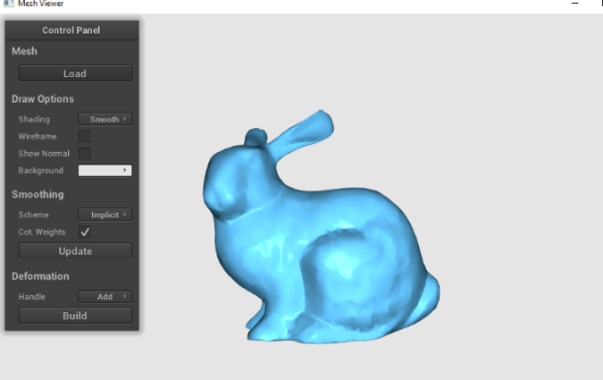

1. Explicit Umbrella Smooth: Uniform-weight Laplacian iteration 0, 10, 30
2. 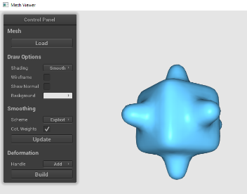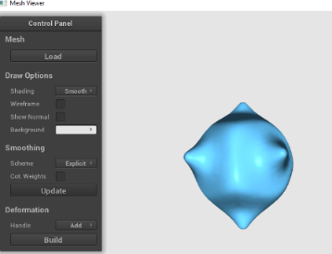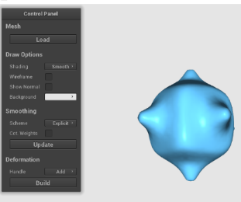

Explicit Umbrella Smooth: Cot-weight Laplacian iteration 0, 10, 30

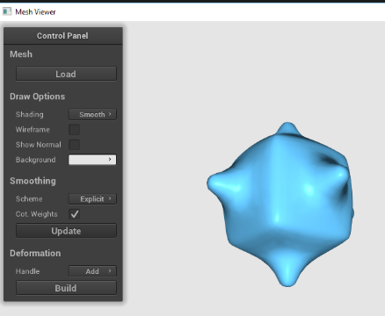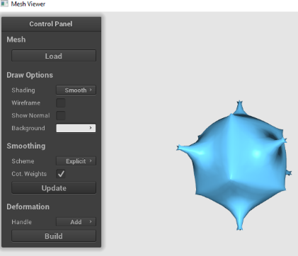

Implicit Umbrella Smooth: Uniform-weight Laplacian iteration 0, 10, 30

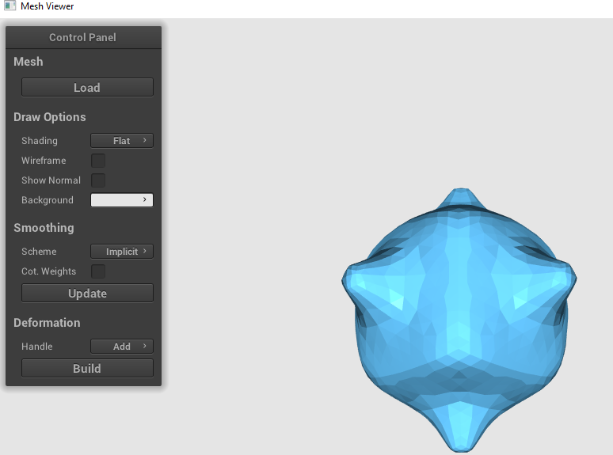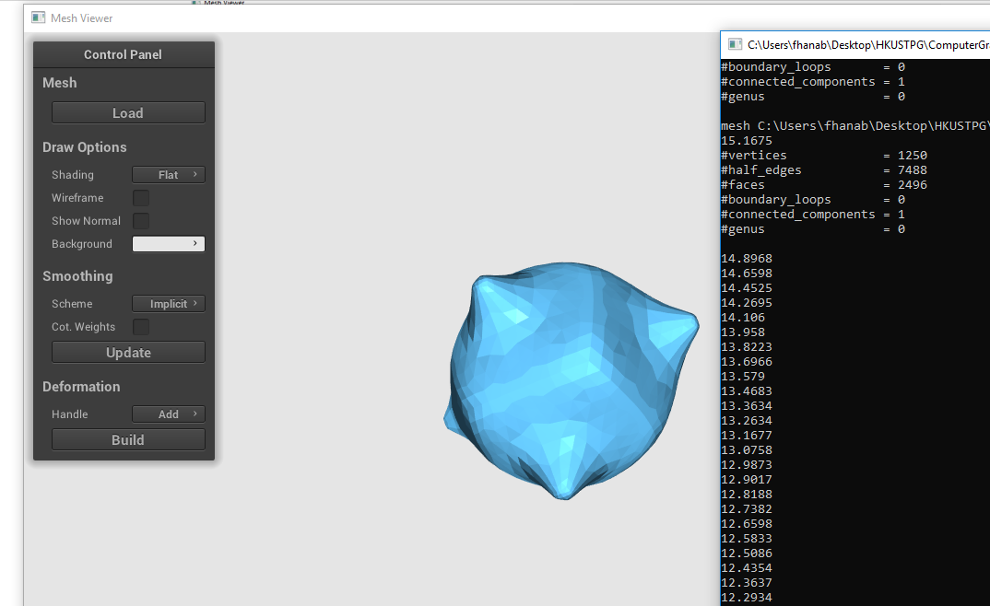

Implicit Umbrella Smooth: Cot-weight Laplacian iteration 0, 10, 30

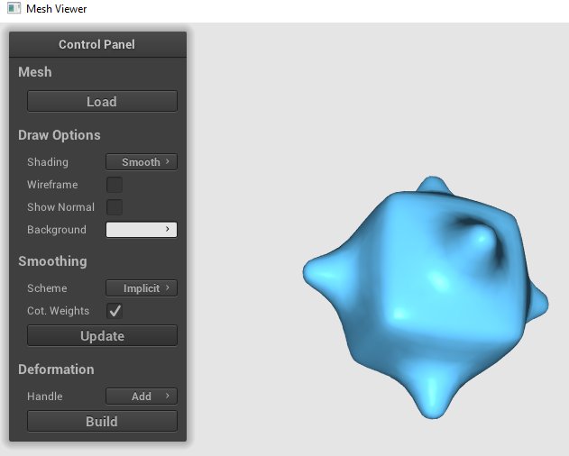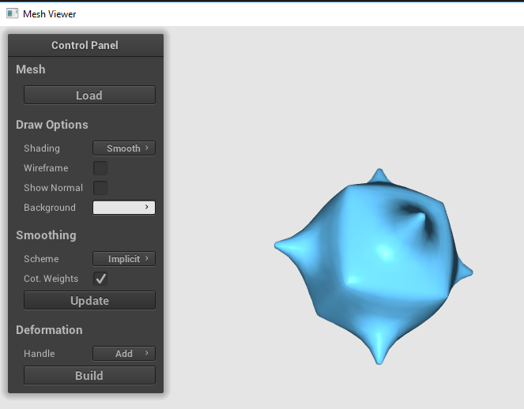

Explicit Umbrella Smooth: Uniform-weight Laplacian iteration 0, 10, 30

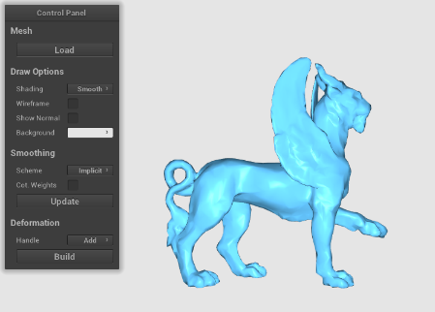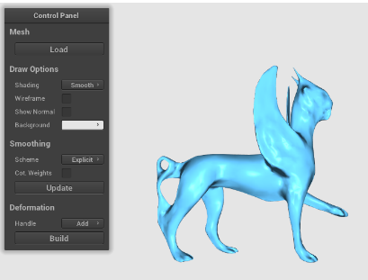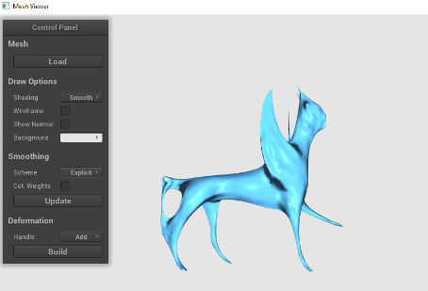

Explicit Umbrella Smooth: Cot-weight Laplacian iteration 0, 10, 30

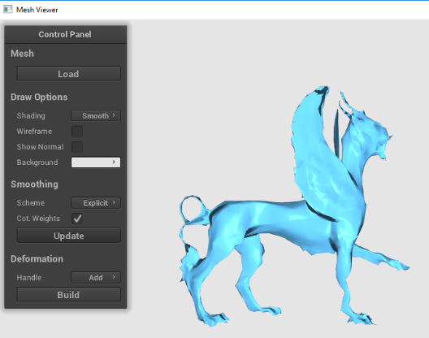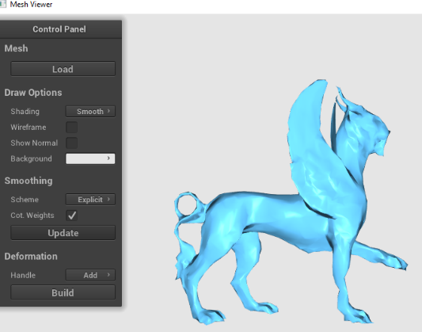

Implicit Umbrella Smooth: Uniform-weight Laplacian iteration 0, 10, 30

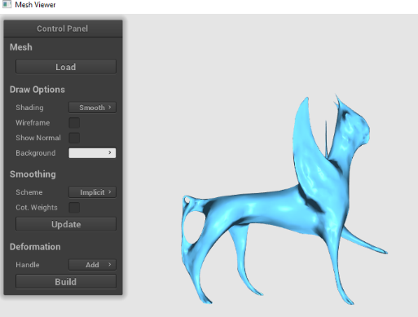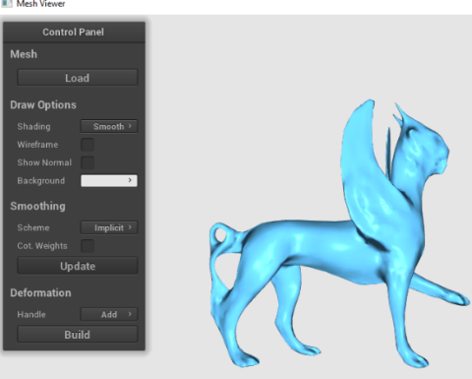

Implicit Umbrella Smooth: Cot-weight Laplacian iteration 0, 10, 30

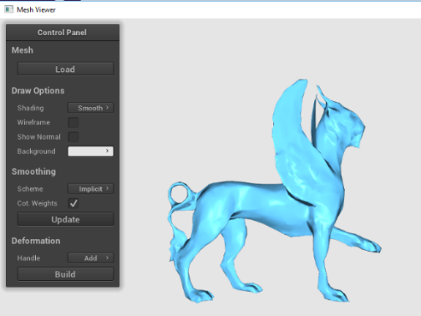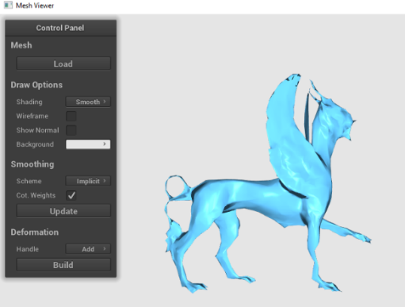

Implicit methods cost less time for the same smoothing results. If lambda is bigger, then the smoothing process will become faster. The value of lambda seems to have effects on how much the vertices move, the larger the lambda is, the more significant shape changing could be observed. However, it will become easier to shrink to a point. The sparseness of Laplacian matrix makes implicit methods efficient. Running time depends on the complexity of objects. Both of the explicit and implicit Laplacian smoothing schemes are able to smooth the surface of the objects, after some number of times. Cotangent weight smoothing seems to perserve the shape of the objects, which may also introduce more minor sharp places  
after smoothing for many times.

Implicit smoothing, compared with explicit smoothing, seems to be better in make the sharp details, like bumpy cube smoothed with cotangent weight. Using uniform weight and cotangent weight will both cause shrinkage after applying Laplacian smoothing. Using cotangent weight helps to reserve the shape. In the implicit method, the smoothing process is more stable and a bit faster. Implicit methods are more time consuming than explicit methods because they solve vertex positions iteratively.

In the experiment the difference is about 0.015 second. For example, cube_bumpy.obj (with 1250 vertices) has the least running time, while the feline.obj (with 4176 vertices) caused crash on my computer.

